**Medina Police Department**

2024 Annual Report

*Edward R. Kinney Chief of Police*

*Dennis Hanwell Mayor*

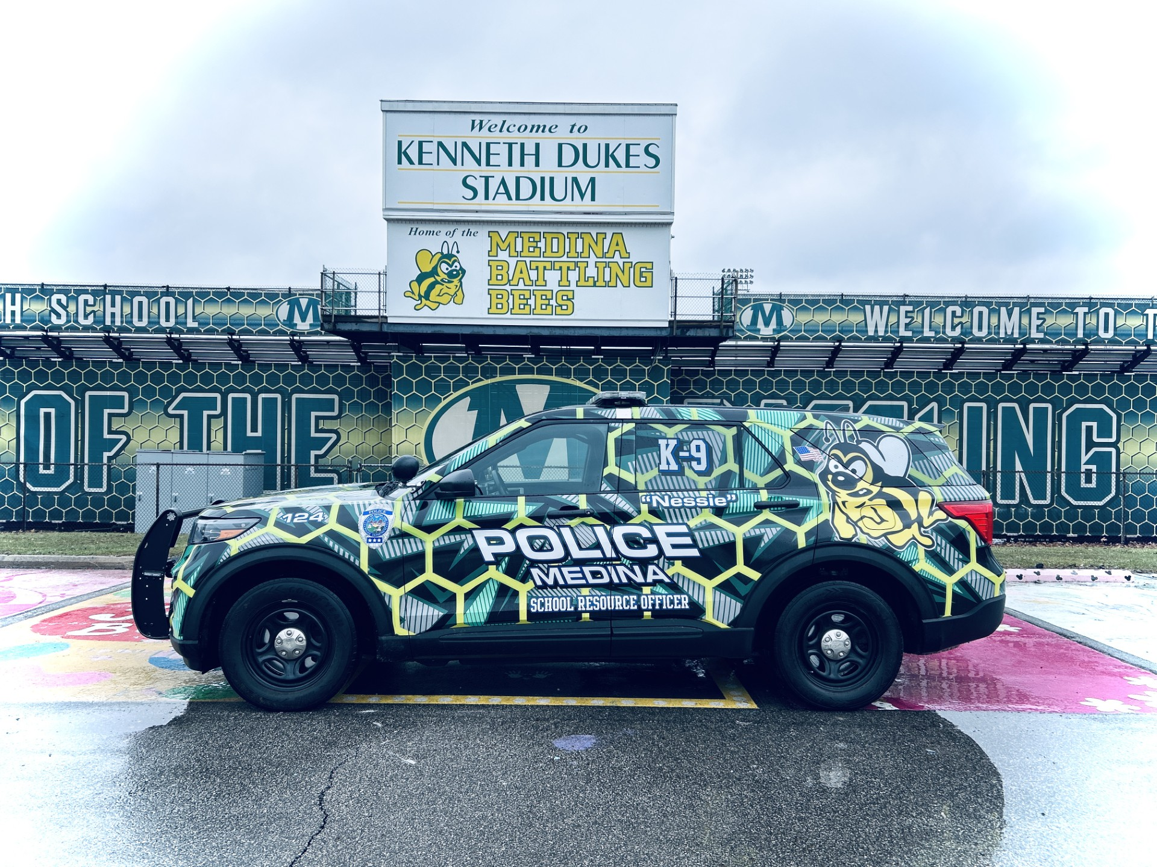

150 W. Friendship St.

Medina, Ohio 44256

330-725-7777

www.medinaoh.org



Mayor Hanwell and Members of Council,

**Medina Police Department 2024 Year-End Report**

I am honored to present the Medina Police Department's 2024 Year-End Report to the Council and our community. Over the past year, we have made significant advancements in technology, enhancing the effectiveness and efficiency of our officers and dispatch personnel. These innovations underscore our unwavering commitment to providing the highest level of service to our community.

**Technological Advancements in Communications**

This year, we upgraded the radio consoles in the Communications Division's dispatch room. These state-of-the-art consoles connect directly to the radio core via a fiber network, significantly improving network connectivity and communication interoperability with neighboring public safety agencies. Additionally, we implemented Multi-Agency Radio Communications (MARCS) capabilities across all dispatch radios, mobile car radios, and portable radios. MARCS enables seamless communication both statewide and locally, enhancing our coordination with other MARCS subscribers and state agencies.

**Enhancements in the Patrol Division**

The Patrol Division has also benefited from substantial technological upgrades. One key improvement is the adoption of a digital fingerprinting system, replacing the traditional ink-and-roller method. This modern system allows officers to quickly capture and upload fingerprints to state and federal databases, increasing accuracy and expediting processing.

We also equipped patrol vehicles with Level 3 ballistic shields designed to provide protection against rifle-caliber rounds. These shields are vital in active shooter situations, ensuring officer safety while enabling immediate responses to threats.

Additionally, we completed a comprehensive upgrade of our body camera and in-car camera systems, adhering to our five-year rotation schedule. Despite extending the legacy system to six years of service, increasing system failures necessitated the upgrade. This investment reinforces our commitment to transparency and accountability.

**Expansion of Flock LPR Camera Network**

This past year, we added two more Flock License Plate Recognition (LPR) cameras to our network, bringing the total to twelve. These cameras have proven invaluable, aiding in the recovery of missing juveniles and endangered elderly individuals, recovering stolen vehicles, and contributing to numerous warrant arrests.

**Partnerships and Community Policing**

Our contract for policing services with Lafayette Township continues to yield positive results. By maintaining the same philosophy of community-oriented policing and dedication to service, we have enhanced public safety, including lifesaving responses to emergency calls in the township.

Our partnership with Medina City Schools remains a cornerstone of our community outreach. We recently welcomed K9 Nessie, a German Shorthaired Pointer, to our K9 program. Acquired using school safety funds provided by Medina City Schools, Nessie works alongside School Resource Officer MacLarren at Medina High School and is trained in bomb and gun detection. Nessie is also available for deployment to other city schools and regional operations, underscoring our dedication to school safety.

We remain committed to fostering strong relationships within our community by actively participating in events such as Shop with a Cop and National Night Out, which create meaningful opportunities for positive engagement and collaboration with the residents we serve.

**Looking Ahead**

As we look forward to 2025, I am deeply grateful for the opportunity to lead this exceptional department. Our commitment to the community remains steadfast, and our department is committed to delivering the highest quality police services to the City of Medina and Lafayette Township.

Respectfully submitted,

Edward R. Kinney

Chief of Police

*City Profile*

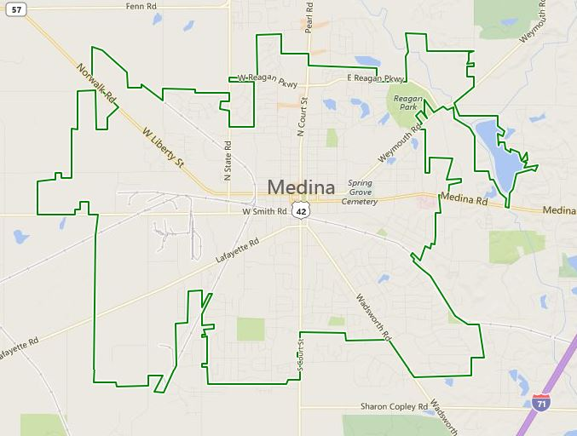

|  |  |  |
| --- | --- | --- |
| **City Motto**  Preserving the Past. Forging the Future. | **Ohio Flag** | **City Logo** |
| **2024 Estimated City Population**  25,826 | **Founded**  1808 | **Incorporated**  1835 Village  1952 City |
| **Square Miles**  11.6 | **Second Largest city in** **Medina County** | **Sixty first most populated city in Ohio** |
| **Transportation Assets**  Rail  Airport | **Estimated Medina County Population**  184,595 | **School District Enrollment**  6,172 |

*Lafayette Township Profile*

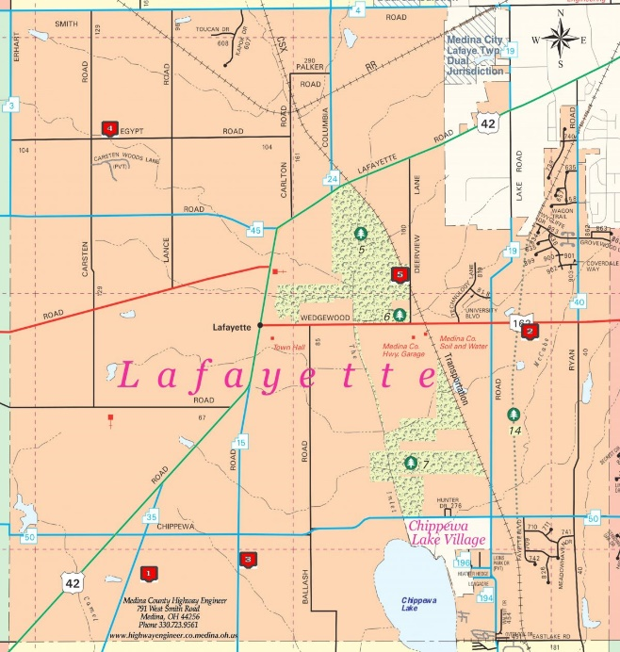

|  |  |  |
| --- | --- | --- |
| **Lafayette Township Population**  6,126 | **Square miles**  22.9 | **Borders**  Southwest side of the  City of Medina |
| **Largest natural lake in Ohio**  Chippewa Lake | **Technology Park**  Medina County University Center  University of Akron | **Settled**  1820 |

*Staff Roster*

Name Assignment Hire Date

Edward Kinney Chief of Police 1997

Scott Marcum Lieutenant 2000

Bryan Wagner Lieutenant 2003

Nathan Simpson Sergeant 2003

Darin Zaremba Sergeant 1995

Patrick Sloan Sergeant 2003

Sara Lynn Sergeant 2005

Joshua Wilson Sergeant 2008

Raven Ory Sergeant 2017

Derek Crooks Sergeant 2014

Daryn Winebrenner Officer 1995

Dan Warner Officer 1995

Todd Grice Officer 1996

Al Roland Officer/SRO 2005

Matthew Martincin Officer 2005

Kelly Moran Officer 2007

Christopher Brink Officer 2008

James Tighe Officer/SRO 2009

Gregory Habrat Officer/Property 2012

James Terwilliger Officer 2013

Nicholas MacLarren Officer/SRO/K9 2013

Michael Wovna Detective 2014

Christopher Deeks Detective 2014

Michael English Detective 2015

Erica Anderson Officer 2015

Andrew Dziak Officer 2016

Christopher Wade Detective 2018

Evan Scherer Officer 2018

Joseph Calabrese Officer 2018

Tyler Hughes/K9 Officer 2019

Matthew Witthuhn Officer 2019

Tyler Howell Officer 2021

Ian Baker Officer 2021

Seth Gonyea Officer 2022

Tyler Thompson Officer 2023

Dalton Weber Officer 2023

Ryan Laskowski Officer 2023

Bailey Hagan Officer 2023

Nicholas Stanton Officer 2024

Kirsten Bache Officer 2024

Tyler Rose Officer 2025

Patty Miller Dispatcher 1999

Denise Indovina Dispatcher 2001

Andrew Demczyk Dispatcher 2013

Crystal Vance Dispatcher 2015

Calvin Undercoffer Dispatcher 2017

Tricia Glauner Dispatcher 2022

Patrick Villeneuve Dispatcher 2022

Jennifer Kehoe Dispatcher 2023

Caitlyn Collins Dispatcher 2024

Ashley Pesata Dispatcher 2024

Summer Gray Dispatcher 2024

Natalie Santivasci Administrative Assistant 2011

Taylor Yaworski Records 2023

Leann Kerr Records 2023

Yvonne Rodman-Sopata Records 2024

Peyton Valentine Records 2024

*Medina Police Department Organizational Chart*

*Department Statistics*

***Lafayette Township Police Service*** *–*

Lafayette Township has retained the Medina Police Department for police services. The current contract is in place through 2027. Last year, MPD officers responded to over 3,700 calls for service originating in Lafayette Township. A glimpse of 2024 activity in Lafayette Township appears in the charts below.

*Patrol Division*

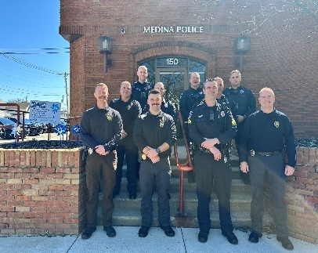

The **Uniformed Patrol Division** serves as the front line of the Medina Police Department, representing the City of Medina and Lafayette Township in response to citizen requests for service. This division is entrusted to initial crime scene investigations, traffic enforcement, motor vehicle accident investigations, and assistance during the Life Support Team (LST) and fire calls. Comprising forty full-time officers, the Patrol Division is under the command of Lieutenant Bryan Wagner.

**Staffing**

In 2024, the Medina Police Department proudly welcomed new members to its team. In July, Officer Nicholas Stanton graduated from the Ohio State Patrol Police Academy. A Loudonville, Ohio native, Officer Stanton has lived in Medina for several years with his wife, Caitlyn. An Eagle Scout and a Baldwin Wallace University graduate with a degree in Criminal Justice, and Officer Stanton exemplifies the department's commitment to recruiting resolute and well-rounded individuals.

At the end of 2024, three new officer candidates received conditional offers of employment. Kirsten Bache and Tyler Rose, both attending the Lorain Community College Police Academy, will graduate in March 2025, while Brandon Johnson will complete his training at the University of Akron Police Academy in April 2025. Upon graduation, all three will officially join the Medina Police Department.

**Recognition and Awards**

In May of 2024, Officer MacLarren was honored for his exemplary work ethic and leadership as a role model within the Medina City Schools, and he earned the "Going the Extra Mile Award" from the Medina City Schools Foundation.

In September 2024, Officer Matthew Witthuhn was honored with an Acts of Heroism Award by the Medina County Safe Communities Committee. Officer Witthuhn demonstrated extraordinary courage by assisting the Lafayette and Medina Fire Departments in saving residents' lives during two separate structure fires. Officer Witthuhn, celebrated for his heroic actions at the Safe Communities annual breakfast, received this award underscoring his unwavering commitment to the community.

**Training and Professional Development**

Training remains a cornerstone of the Medina Police Department's mission to provide exemplary service. In 2024, the department exceeded the Ohio Attorney General's mandate of 24 hours of continuing education for officers. Training sessions included:

* Legal updates
* Defensive tactics
* Firearms proficiency
* Emergency vehicle operations
* Public records law
* School-based policing
* Supervisory courses
* Active threat incident response
* Patrol interdiction
* Critical intervention

Additionally, in June 2024, Lieutenant Bryan Wagner graduated from the prestigious Public Safety Leadership Academy (PSLA) at Ohio State University. This rigorous 11-week residential program cultivates strong leadership in law enforcement. The curriculum included advanced courses in public budgeting, human resource management, strategic planning, program implementation, organizational theory, communications, and social media strategies. Lieutenant Wagner's achievement highlights the department's dedication to leadership development and continuous improvement.

**VEHICLE PURSUIT REVIEW**

Deciding whether to initiate a vehicle pursuit is a critical decision, often under challenging and unpredictable conditions. Officers must balance the need for apprehension with the safety of the public, fellow officers, and the suspect during a vehicle pursuit. Therefore, sound judgment and self-discipline are paramount in ensuring the most effective and responsible decision-making process.

Officers must remain focused on adhering to department policies and exercising professional judgment throughout a pursuit. The overarching principle is that the officer's actions must be "objectively reasonable," meaning they should align with what a reasonable officer would do under similar circumstances, considering the facts and conditions at the time.

In 2024, the Medina Police Department responded to and conducted eight vehicle pursuit incidents. Each of these pursuits proved to be in accordance with established policies after a thorough review. The review process involves collecting and analyzing the corresponding incident reports, evidence, and video footage to ensure compliance with departmental standards.

Upon review, all eight vehicle pursuits complied with the Medina Police Department's Policy Manual, Section 314 – Vehicle Pursuits. This policy ensures that officers are consistently making informed, safety-conscious decisions amid dynamic and potentially hazardous situations.

**USE OF FORCE REVIEW**

The Medina Police Department recognizes and respects the value of all human life and dignity without prejudice. Granting officers the authority to use reasonable force to protect the welfare of the public requires rigorous monitoring, evaluation, and a careful balancing of all interests.

In 2024, the Medina Police Department used force in fourteen incidents. Each of these incidents underwent a thorough review process. The review process included analyzing incident reports, use-of-force reports, video evidence, and all supporting documentation to ensure compliance with Medina Police Department Policy 300.4, which governs the reporting of use-of-force incidents.

All fourteen incidents were compliant with Policy 300.4. The following chart provides a demographic breakdown of individuals involved in these incidents:

|  |  |
| --- | --- |
| **Demographic** | **Number of Incidents** |
| White Males | 8 |
| White Females (Juvenile) | 1 |
| Black Males | 5 |
| Black Females | 0 |

This data reflects the department's commitment to transparency and accountability while ensuring adherence to policy and proper oversight in all use-of-force situations.

**CANINE UNIT OVERVIEW**

**2024 Canine Statistics**

|  |  |
| --- | --- |
| **Deployment Type** | **Count** |
| Total Deployments | 77 |
| Traffic Stops | 32 |
| Arrests | 4 |
| COP Deployments | 35 |
| Call-Outs | 1 |
| Other Deployments | 5 |

Shape

**Nessie: School Resource Canine**

In Spring 2024, the Medina Police Department initiated the process of acquiring a new Canine for Medina High School. Officer Nicholas MacLarren won the honor of becoming the handler for Nessie, a one-and-a-half-year-old German Shorthaired Pointer bred in the Netherlands.

Nessie and Officer MacLarren underwent extensive training at Shallow Creek Kennels in Pennsylvania, becoming certified in explosives and firearm detection. By September 2024, they completed training and received certifications from both the State of Ohio and the North American Police Work Dog Association (NAPWDA).

**Key Highlights:**

* **Daily Patrols:** Nessie patrols Medina High School hallways daily.
* **Emergency Response:** Ralph E. Waite Elementary called on Nessie for a school search after ammunition was located on a school bus.
* **Community Engagement:** Officer MacLarren and Nessie actively engage with the community by attending after-school sporting and arts events, city parades, and other activities.

Shape

**Tango: Patrol Canine**

Tango, the department's second Canine, completed his first full year as a patrol dog in 2024. Tango assisted officers in various scenarios, including traffic stops, building searches, and suspect tracking. He also supported outside agencies, including:

* **Wadsworth PD**
* **Montville Twp. PD**
* **Medina Twp. PD**
* **Brunswick PD**
* **Medina County Sheriff's Office**
* **Medina County Drug Task Force**
* **Ohio State Patrol**

**Enforcement Highlights:**

* Assisted in traffic stops, resulting in seizures of felony drugs.
* Tracked and apprehended multiple suspects wanted for violent and felony crimes.

**Community Involvement:** Tango participated in many public events, including:

* Touch a Truck
* July 4th Fireworks
* Visits to Hope and Healing
* Kiwanis Club meetings
* Demonstrations at Medina Municipal Airport
* National Night Out

Shape**Summary**

The Canine Unit continues to play an essential role in the Medina Police Department's mission, enhancing safety, enforcement, and community outreach efforts. With Nessie's addition and Tango's proven capabilities, the department's Canine Unit remains a cornerstone of operation.

**SCHOOL RESOURCE OFFICERS**

The Medina Police Department proudly provides three full-time School Resource Officers (SROs) who work collaboratively with the Medina City School District to ensure a safe and supportive learning environment. These positions are partially funded by the Medina County Drug Advisory Committee (MCDAC) grant, which was established through the county's anti-drug levy. Under the command of Lieutenant Scott Marcum, the SRO team consists of:

* **Officer Nicholas MacLarren** – assigned to Medina Senior High School
* **Officer Al Roland** – assigned to A.I. Root Middle School
* **Officer James Tighe** – assigned to Claggett Middle School

Each SRO operates based on the triad concept, serving as a law enforcement officer, educator, and mentor. Their primary mission is to create a safe and positive school environment for students, faculty, and the community.

**Law Enforcement & Community Collaboration**

As law enforcement officers, the SROs handle all calls for service within their respective schools. They work closely with agencies such as the Medina County Health Department and Medina County Job and Family Services, reinforcing a collaborative approach to student safety and well-being. More than just a security presence, the SROs serve as liaisons between law enforcement and students, fostering trust and positive relationships in a non-confrontational setting.

**Mentorship & Student Support**

Beyond their law enforcement duties, the SROs actively mentor students, working alongside school administrators, counselors, social workers, and teachers to support student development. Officers MacLarren, Roland, and Tighe are dedicated to mentoring at-risk youth, investing additional time to build rapport and provide guidance, particularly to students with special needs.

**Specialized Programs & Engagement**

* 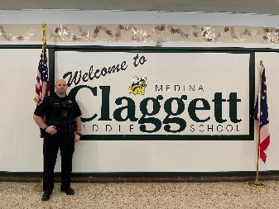**Officer James Tighe – D.A.R.E. Instructor**   
  Officer Tighe takes on additional responsibilities as a certified Drug Abuse Resistance Education (D.A.R.E.) instructor, leading lessons for 5th-grade students. D.A.R.E. is one of the most comprehensive drug prevention programs in the world, covering topics such as bullying, internet safety, social media awareness, vaping, and the harmful effects of drug use. Through scenario-based activities, Officer Tighe helps students develop critical decision-making skills that promote healthy, positive lifestyles.
* 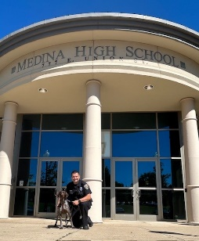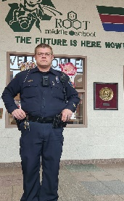**Officer Al Roland – A.I. Root RC Club Coordinator**   
  Officer Roland is actively involved in after-school programs, particularly as the coordinator of the A.I. Root Middle School RC Club. A longtime radio-controlled (RC) car enthusiast, he shares his passion with students, guiding them in building and operating RC vehicles. This unique program provides students with hands-on experience in mechanics, engineering, and teamwork.
* **Officer Nicholas MacLarren & K-9 Nessie**   
  This year, Officer MacLarren welcomed a new partner—Nessie, a highly trained German Shorthaired Pointer specializing in firearm and explosive detection. Nessie has quickly become a favorite among students, enhancing school safety while also providing a friendly and approachable presence in the hallways.

**Building Bridges Between Law Enforcement & Education**

While safety remains the primary objective of the Medina Police Department's School Resource Officers, their impact extends far beyond security. They play a vital role in bridging the gap between law enforcement, students, faculty, and the community—promoting understanding, mentorship, and collaboration. Through their dedication, the SROs continue to foster an environment where students feel safe, supported, and empowered to succeed.

**COMMUNITY OUTREACH**

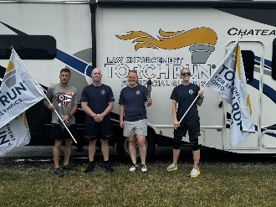Throughout the year, officers commit time to connecting with the community on an amicable level. They extend reasonable training and expertise and attend and participate in many community events. They stop and chat when time allows and bike through neighborhoods. Officers attended many community events throughout the year. Some of the events include Easter Egg Hunts, National Night Out, Bike to School, Touch a Truck, Juneteenth Festival, Halloween events, Candlelight Walk, Kids Day on the Square, Visit from Santa, Shop with a Cop, various job fairs and block parties and many other community events. The Annual Special Olympics Torch Run came through Medina once again. Lieutenant Bryan Wagner, Sergeant Nathan Simpson, Sergeant Raven Ory, and Officer Erica Anderson carried the Flame of Hope in support of the mission. Many Officers also participated in the Tunnels to Towers 5K, several in full uniform. Here are a few additional highlights:

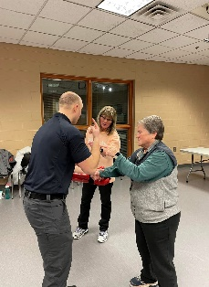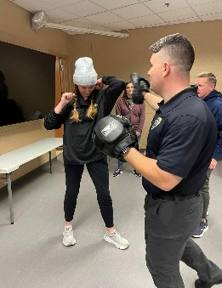**Women's Self-Defense Class** Medina Police Officers taught Women's Self-Defense classes in 2024. This five-week instructional course hosted at the Medina Rec Center teaches women personal safety and various techniques, including striking, escaping, and countering an attack. On the final day of class, participants adorn protective pads and use their new skills to simulate real-life scenarios.

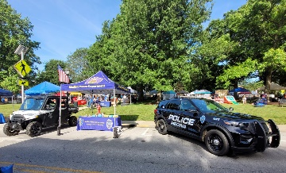**Kids Day of Safety and Play, Touch a Truck & National Night Out**

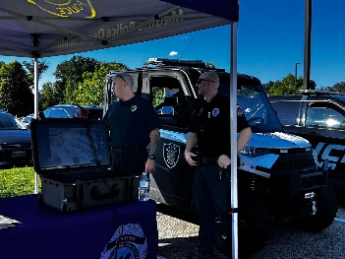During the Summer of 2024, Medina Police Officers engaged with the community during several events, including the Kids Day of Safety and Play on Public Square, National Night Out, and Touch a Truck hosted at the Medina Recreation Center parking lot. Officers open and display police vehicles for children to sit in and tour, demonstrate equipment, engage with attendees, and give out coloring books, pencils, stickers, and even apply temporary tattoos on children attending.

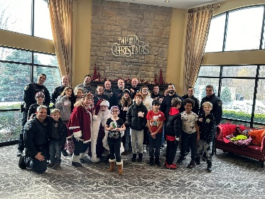**Shop with a Cop**

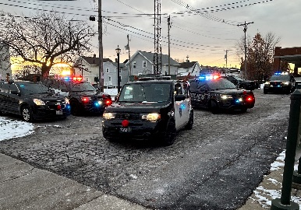The Fraternal Order of Police Lodge #204 supports this county-wide event and rallies together many county organizations to spread the joy of Christmas. Numerous departmental members represented The Medina Police Department and hosted eighteen children this year. First responders and volunteers from around the county accompany less fortunate children through a day of holiday activities, including a visit from Santa, breakfast, transport in a lights and siren vehicle parade, shopping at Walmart, and lunch with many special treats and fun. We appreciate the dedicated support and widespread community generosity that elevate this event.

**Juvenile Diversion**

The Medina Police Department participates in the Medina County Juvenile Traffic Diversion Program. A program is offered to all first-time juvenile traffic offenders aged 16 or 17. The one-day class provides an alternative to the Juvenile Court system for an initial offense. Candidates experience a classroom environment hosted by officers and learn safe driving techniques through simulators and direct driving exercises. Participation requires a fee of $50, which covers the administrative costs. Upon completing the program, neither the juvenile nor their parent(s) need to appear in court. Thus, the juvenile's driving record remains clear. Medina Police referred eighty-one juveniles to the program in 2024.

**MEDINA COUNTY SWAT & CRISIS NEGOTIATION TEAM**

The Medina County Special Weapons and Tactics Team (SWAT) is a multi-jurisdictional team that services the communities of Medina County. The SWAT team is led by the Medina County Sheriff's Office and is comprised of members from the jurisdictions of Medina PD, Wadsworth PD, Brunswick City PD, Montville Township PD, Medina Township PD, Hinckley Township PD, Brunswick Hills Township PD, Medina County Drug Task Force, and the Medina County Sheriff's Office. The Medina Police Department dedicates three officers to SWAT. Additionally, the Crisis Negotiation Team is a multi-jurisdictional team that serves the county. Medina Police Department dedicates an additional officer to this team.

**2024 SWAT Statistics**

|  |  |  |
| --- | --- | --- |
| **Operation** | **Number** | **Communities Involved** |
| Search Warrant | 3 | Medina City, City of Brunswick, York Township |
| Arrest Warrant | 2 | City of Cleveland, Granger Township |
| Barricaded Subjects | 1 | Hickley Township |
| Hostage Rescue Situation | 1 | Medina Township |

In 2024, Medina County SWAT accrued 204 hours of training, well above the yearly standard set by the National Tactical Officers Association. Training topics included tactical medicine, de-escalation techniques, advanced marksmanship/weapons manipulation, vehicle interdiction tactics, chemical munitions, impact munitions, barricaded subjects/suspects, hostage rescue, close-quarters combat, defensive tactics, covert surveillance, and operation planning.

*SPECIAL OPERATIONS DIVISION*

**Detective Bureau**

Lieutenant Scott Marcum oversees the Detective Bureau, which is tasked with investigating felony and misdemeanor cases and conducting pre-employment background investigations. Most cases handled by the Detective Bureau originate from the Patrol Division and are forwarded for additional investigation.

Detectives are responsible for managing cases through the entire investigative process, including court proceedings. The Detective Bureau is staffed with four detectives who rotate through a weekly on-call schedule, responding from home to emergency investigations as needed.

One detective is currently assigned as a liaison to the Medina County Drug Taskforce, assisting with search warrants and undercover drug operations. Additionally, detectives participate in the Child Abduction Response Team (CART), a county-wide, multi-jurisdictional team. CART detectives receive ongoing training and engage in scenarios specific to cases involving missing or abducted children and at-risk adults.

In 2024, the Detective Bureau handled 383 cases. Cases are triaged before assignment to prioritize those with actionable leads or evidence, ensuring a focus on solvable cases. Over 140 cases were presented to the grand jury, resulting in 177 felony charges. Detectives obtained more than 25 search warrants and submitted countless grand jury subpoena requests. Additionally, 16 cases involved digital forensics, and detectives completed eight pre-employment background investigations.

*Communications/Dispatch*

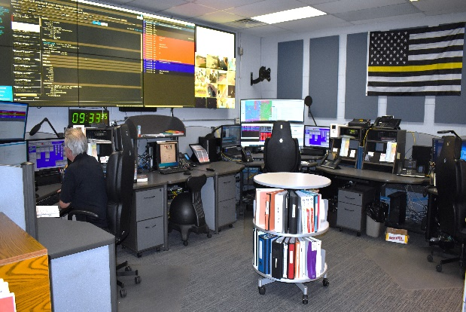The Medina Police Department Communications Center serves as a critical hub for dispatch services, supporting five first responder agencies, including police, fire, and EMS. Dispatch services are provided directly to the Medina Police Department and Medina Fire Department, with additional contracted support for the Montville Township Police Department, Medina Township Police Department, and Cleveland Clinic's Life Support Team. Operating 24/7/365, the Communication Center also acts as the primary point of contact for all City services outside regular business hours.

**Call Volume and Performance Metrics**

In 2024, the Communications Center demonstrated exceptional efficiency and dedication, managing:

* 72,361 Calls for Service (CFS) across the five agencies served.
* 10,259 emergency 9-1-1 calls.
* 79,369 non-emergency calls.

Dispatch operators excelled in responsiveness:

* 99.42% of 9-1-1 calls answered in under 15 seconds.
* 99.57% of 9-1-1 calls answered in under 20 seconds.
* 86% of 9-1-1 calls answered in under 3 seconds.

These metrics significantly exceed the Ohio Administrative Code standards, which require 90% of calls answered within 15 seconds and 95% within 20 seconds.

**Technological Advancements**

In April 2024, the Communications Center completed a significant radio console upgrade, marking the culmination of a three-year project. The three workstations now boast state-of-the-art Harris Symphony radio consoles and monitors. Additional key enhancements include:

* Transition to headsets, allowing dispatchers to manage 9-1-1 calls and radio traffic hands-free.
* Reduction in ambient noise, creating a quieter and more focused work environment.

These upgrades improve operational efficiency and contribute to a calmer, more professional atmosphere in the communications center.

**PSAP Designation and Wireless 9-1-1 Calls**

As of 2024, the Medina Communications Center achieved Primary Public Safety Answering Point (PSAP) status, a significant milestone. This designation enables the center to receive wireless 9-1-1 calls directly. Key updates include:

* July 2024: Verizon Wireless 9-1-1 calls began routing directly to Medina PSAP.
* September 2024: We added AT&T wireless 9-1-1 calls.
* By year-end, T-Mobile wireless calls are on track to complete the transition.

This shift eliminated the previous need to route wireless calls through the Medina County Sheriff's Dispatch Center, streamlining response times and improving service delivery.

**Staffing Updates**

The Communications Center welcomed three new dispatchers in 2024:

* Caitlyn Collins (May 2024)
* Ashley Pesata (August 2024)
* Summer Gray (December 2024)

Caitlyn and Ashley have successfully completed their training programs and actively contribute to the team. Summer Gray is currently in the first phase of her training. These additions fully staff the dispatch center, reflecting the department's commitment to maintaining high operational standards.

Additionally, the Communication Center serves as a point of contact for all City services outside regular business hours since the communication center operates 24 hours a day, 365 days a year.

**RECOGNITION AND AWARDS**

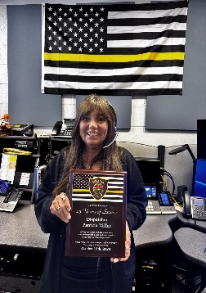Dispatcher Patty Miller celebrated a milestone of 25 years of service to the Medina Police Department.

Dispatchers Ashley Pesata and Jennifer Kehoe were recognized for their exemplary communication skills on November 11th, 2024, when an active Amber Alert out of Jefferson County, Ohio, led to a pursuit in Medina County. The suspect fled in a U-Haul truck, and Brunswick officers pursued the suspect into Medina Twp. The suspect, holding his 7-year-old daughter hostage at gunpoint, called 9-1-1 and first spoke with Dispatcher Pesata. Pesata spent over 12 minutes on the phone attempting to de-escalate his behavior and save the hostage. The suspect called 9-1-1 again and was connected to Dispatcher Kehoe on the other end. Dispatcher Kehoe also used de-escalation skills through conversation to keep him calm. The standoff ended with the 7-year-old uninjured and the suspect deceased. Dispatcher Pesata is credited with helping save the child's life through her calm demeanor while engaging in conversation with the suspect.

*Property/Evidence*

The property officer ensures the proper collection, preservation, storage, security, and disposition of evidence and other property. Evidence is maintained only as long as necessary for any ongoing investigation or prosecution. Non-evidentiary property is retained until it can be returned to its rightful owner or otherwise disposed of in accordance with the law.

The department follows rigorous procedures to ensure the integrity of the chain of custody for all items stored in the facility. Regular audits and inventory checks are conducted to maintain accountability and compliance with state and federal regulations. The Property and Evidence Room plays a critical role in supporting the department's mission to uphold justice by preserving evidence for court proceedings and ensuring proper handling and return of personal property to rightful owners.

**Summary of Activities:**   
The MPD Property Room received and managed significant property-related tasks in 2024. Below are key highlights:

1. **Property Inventory:**

* As of the end of 2024, the Property Room holds 5,079 items of property.

1. **Property Received:**

* A total of 696 items were received, including:
* 116 items classified as drugs or drug paraphernalia.

1. **Property Disposition:**

* 834 items were removed from the Property Room, including:
* 658 items forfeited.
* 680 items were destroyed.
* 32 items were auctioned.
* 122 items returned to their rightful owners.

1. **Prescription Drug Drop Box:**

* The Prescription Drug Drop Box, located in the Police Department lobby, collected a total of 352.4 lbs. of unused medications.

|  |  |  |  |  |  |  |
| --- | --- | --- | --- | --- | --- | --- |
|  | PROPERTY RECEIVED | NARCOTICS | BCI LAB SUBMISSIONS | ITEMS DESTROYED | ITEMS FORFEITED | ITEMS AUCTIONED |
| 2024 | 696 | 116 | 62 | 680 | 658 | 32 |
| 2023 | 1217 | 377 | 123 | 540 | 620 | 35 |
| 2022 | 1023 | 285 | 123 | 1058 | 674 | 33 |

**Goals for 2025:**

* Maintain the current level of efficient operations.
* Conduct a thorough review of older property to determine eligibility for forfeiture or return to the rightful owner.

*Records Department*

The Records Division of the Medina Police Department plays a vital role in ensuring the efficient and accurate management of all departmental documentation and information. This division is responsible for processing, maintaining, and safeguarding a wide range of records, including incident and accident reports, citations, arrests, and other official documentation.

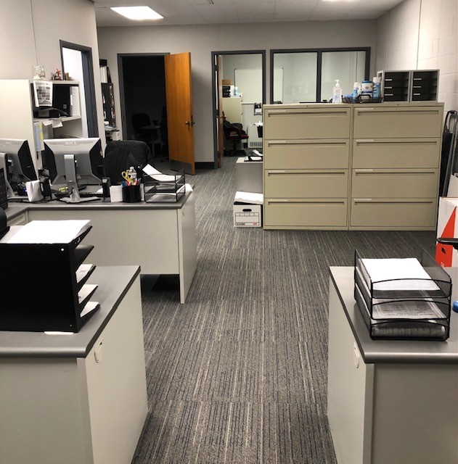

The Records Division provides critical support to the department by ensuring timely access to accurate data for investigations, administrative purposes, and legal proceedings. It also serves as a point of contact for the public, offering services such as report requests, background checks, and records inquiries, all while adhering to local, state, and federal regulations regarding the confidentiality and dissemination of information.

Records division personnel are committed to maintaining the highest standards of integrity, professionalism, and efficiency in all operations, aligning with the mission of the Medina Police Department to serve and protect the community.

*Police Specials Unit*

The Medina Police Department's "Specials Unit" was established in April of 1958. At that time, nine community members formed the volunteer unit to assist and supplement the Medina Police Department. Over the years, the unit has grown and evolved. Still, one aspect remains the same: the unit members continue to donate thousands of volunteer hours to the community and the police department. Our Specials Unit consisted of seventeen members in 2024. Ten members are OPOTC state-certified and held to the same standards for training as full-time officers. All members are regularly trained to handle medical emergencies.

In 2024, members volunteered 1,226 hours to the community and MPD. Specials accumulate hours by attending monthly meetings, fulfilling training requirements, riding with officers, working paid details, and, most importantly, working volunteer details. The Specials Unit provides security and traffic control at most community and school events.

Three new volunteers joined the Specials Unit in 2024. Thomas Dickel and Brian Ohlin, both retired police officers, have maintained their peace officer certification. Additionally, Ron Ross, a retired sergeant from the Medina Police Department, joined the unit.

Two long-term volunteers resigned from the unit. Special Officer Michelle Eierdam resigned as she has relocated to another state. Bob Andrews, a member of the unit since 1970, retired. Andrews attended the Ohio State Highway Patrol Academy in 1971 and maintained his certification throughout the years. Bob volunteered for the City of Medina for 54 years!

The Specials Unit offers caring, selfless support to the many community events that would not run smoothly without their presence. We are grateful for their selfless service in the Medina community. The members of the Specials Unit are proud to continue their legacy of excellence and service into 2025.

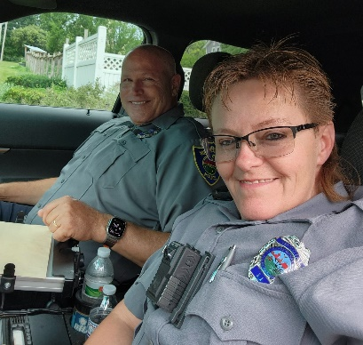 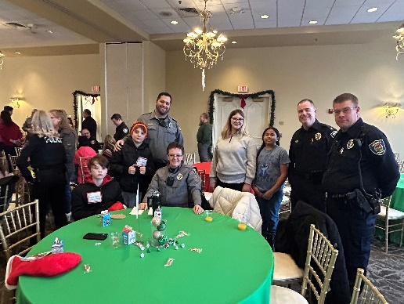 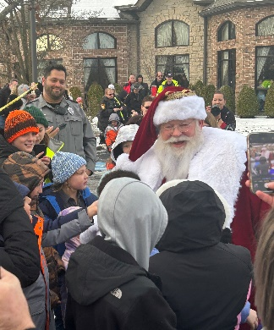

Annual First Responder Luncheon

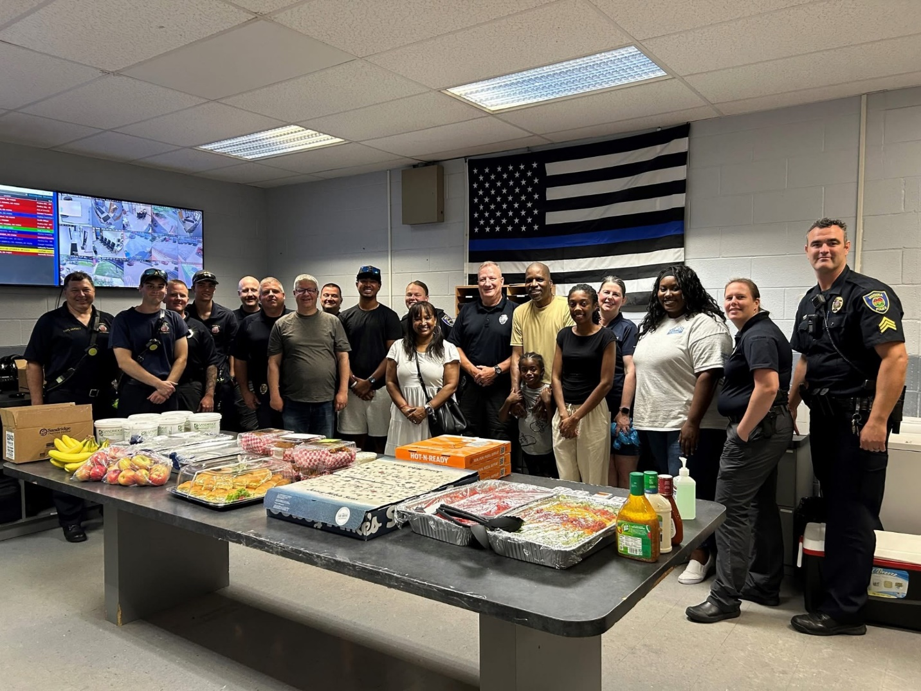

Each year, the Second Baptist Churchs’ Pastor Ruffin and his family collaborate with many area churches and businesses to offer first responders around the Medina area a delicious spread. The event is hosted at the Medina Police Department, and neighboring agencies take time to visit and enjoy. This event cultivates warmth and camaraderie between agencies and with the community. We are grateful for all involved in supporting this event.